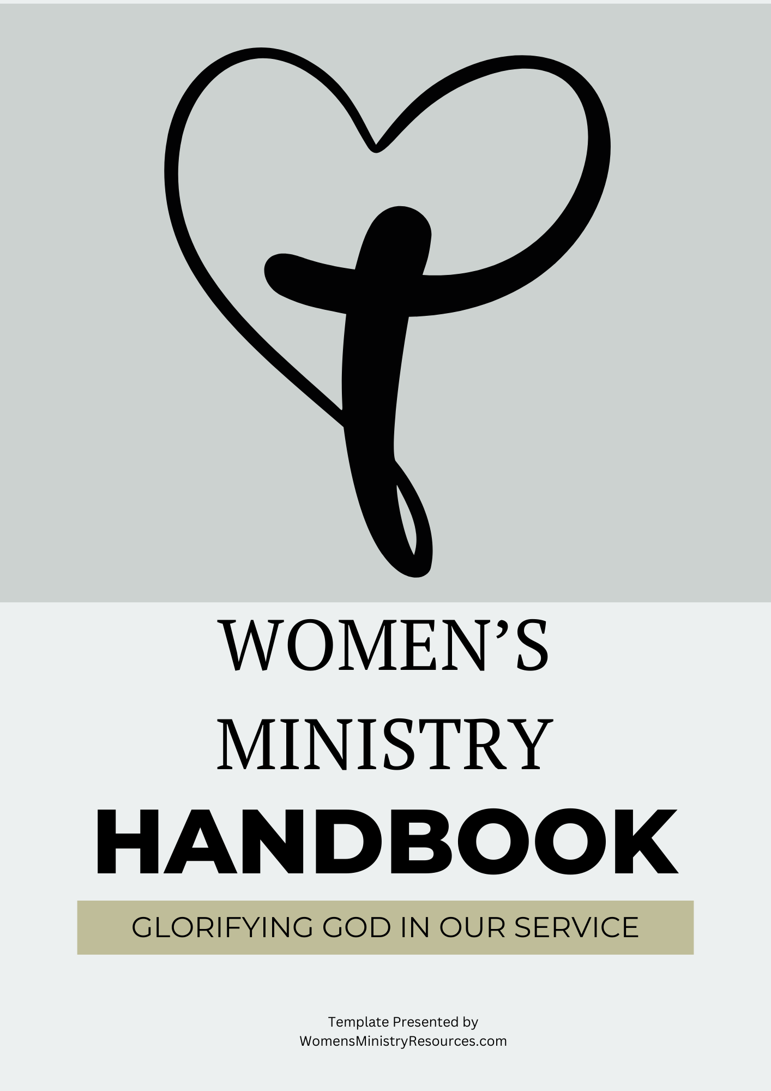

Table of Contents
Welcome to the Team! 3
Introduction 4
1. Women’s Ministry Vision and Mission 4
2. Key Leadership Roles & Responsibilities 5
3. Core Values and Statement of Faith 6
4. Ministry Structure & Organization 7
5. Meeting Guidelines & Frequency 7
6. Programs & Events 8
7. Conflict Resolution & Team Unity 8
8. Financial Stewardship & Budgeting 9
9. Code of Conduct 9
10. In Conclusion 10

Welcome to the Team!
We are so excited and grateful to have you join us on this incredible journey of serving and encouraging women.
The ministry leader makes the formal appointment and will advise you why you are receiving this handbook. It may be because you’re fully appointed! I may be given to you to help you make a decision.
Regardless of why, we thank God for you and trust His plan.
Your gifts, passion, and heart for ministry are truly valued, and we can’t wait to see how God will work through you.
As a team, we support one another, pray for each other, and work together to create meaningful opportunities for women to grow in faith, fellowship, and purpose.
No one serves alone here—we are in this together! Know that you are not just stepping into a role; you are stepping into a community that will uplift, equip, and empower you.
We believe God has great things in store, and we are so blessed to have you be a part of it! Welcome aboard!

Introduction
This handbook is a comprehensive guide for those leading or participating in the Women’s Ministry. It establishes clear expectations, best practices, and a robust framework for creating a thriving and spiritually impactful ministry.
This handbook aims to empower women’s ministry leaders and participants alike to foster an orderly ministry by outlining essential principles and practices.
Additionally, it includes valuable insights on how to effectively navigate challenges, celebrate successes, and cultivate an inclusive environment that welcomes all women to engage and grow in their faith journey.

Overall expectations for any helper (i.e., volunteer)
Overall expectations for any helper (i.e., volunteer) are to demonstrate a strong commitment to women’s ministry and the mission of this women’s ministry.
This includes engaging in various tasks and contributing their time and skills effectively and efficiently.
All volunteers must be reliable, punctual, and open to feedback.
Feedback is a gift and should be sought out in humility and received in love.
Every ministry team member must be willing to collaborate with other team members.
Doing so will promote a positive and productive women’s ministry environment.
Additionally, it's important for volunteers to possess a genuine passion for women’s ministry.
In doing so, the expectation is that they show empathy and respect toward the women served by the ministry.
A growth mindset is an expectation. Everyone on the leadership team should consistently embrace the opportunity to learn and grow through their volunteer experience.
By embodying these qualities, volunteers can truly make a significant impact with the women’s ministry group and the church as a whole.

Women’s Ministry Vision and Mission
Our Women’s Ministry exists to:
- Encourage and equip women to grow in their faith.
- Build a supportive and nurturing Christian sisterhood.
- Serve the community through love and action.
- Provide discipleship and mentorship for women of all ages.

Key Leadership Roles & Responsibilities

Women’s Ministry Leader
The expectations of the women's ministry leader include but are not limited to, fostering a supportive environment where all women can grow spiritually, emotionally, and socially.
Oversight includes leading a women’s ministry team to organize events that not only strengthen sisterhood bonds among the women in the church but also the team of volunteers.
The leader's primary role is to set the vision for the work.
A good leader also values her team.
This means she is committed to inspiring the personal growth and leadership skills of the women who serve with her.
She will intentionally create opportunities for women to test their capacity by trying new things with the comfort of knowing she supports their efforts.
As a servant leader, she will step into situations to help as the team needs it.
A key expectation is that the women’s ministry leader intentionally provides mentorship opportunities within the leadership team. Collaboration is a core value and expectation of the women’s ministry leader. She will also encourage women to take on active roles within the church and beyond.
As a leader, she will cooperate with the team to reach a consensus, but she guides the direction of the women’s ministry, meaning she may often have to make unpopular decisions.

Specific Leadership Tasks
Specific duties of the women's ministry leader include, but are not limited to:
- delegation of responsibilities to team members
- fostering collaboration among volunteers
- ensuring effective communication within the ministry
- communicating regularly with church leadership to ensure the women’s ministry’s activities align with the church’s goals and objectives
Additionally, the women’s ministry leader will assess the unique strengths of each volunteer on her team.
She will strive to provide ample opportunities for them to take on roles that align with their gifts.
Finally, she will attend meetings and consistently lead the women with excellence, clarity, and vision.

Assistant Ministry Leader
An assistant women's ministry leader plays a crucial role by supporting the main leader and stepping in to assume responsibilities whenever needed. This includes various tasks, such as meticulously planning and overseeing ministry activities while ensuring that these events align with the ministry's overall vision.
She will also communicate with other members, fostering a sense of community and encouraging participation. By collaborating closely with the leader, the assistant women's ministry contributes to developing programs that address the unique needs and interests of women within the congregation, thereby enhancing spiritual growth and connection among the members.

3. Core Values and Statement of Faith
- Rooted in Scripture (2 Timothy 3:16-17)
- Committed to unity and sisterhood (Romans 15:5-6)
- Focused on serving others (Galatians 5:13)
- Dedicated to prayer and intercession (1 Thessalonians 5:16-18)

Our Core Values
Our values and faith are rooted in scripture, as highlighted in 2 Timothy 3:16-17. Our women's ministry embraces the profound truth that all Scripture is God-breathed and is essential for teaching, rebuking, correcting, and training in righteousness.
This foundation empowers us to cultivate strong spiritual growth and a deep understanding of God's word.
This women’s ministry is committed to unity and sisterhood.
We take inspiration from Romans 15:5-6, encouraging one another to live in harmony and be united in mind and voice, fostering a supportive community that reflects Christ’s love.
Our mission also emphasizes serving others, as guided by Galatians 5:13.
We are called to use our freedom to serve one another in love, recognizing that true empowerment comes through acts of kindness and compassion.
Finally, our women’s ministry is dedicated to prayer and intercession; we follow the instruction in 1 Thessalonians 5:16-18 to rejoice always, pray continually, and give thanks in all circumstances, ensuring that our ministry is enveloped in a spirit of prayer, seeking God’s guidance in all our endeavors.
Together, these values shape our mission to grow closer to God, build meaningful relationships with one another, serve our communities, and uplift each other through prayer.

4. Ministry Structure & Organization
Our ministry operates under the church leadership, fostering a strong connection with the overall mission of our church.
Regular team meetings, such as monthly planning sessions and quarterly retreats, ensure unity and effectiveness among members by providing a structured opportunity for collaboration and communication.
These gatherings facilitate the sharing of ideas and updates and foster a sense of camaraderie and shared purpose. Attendance is a requirement.
Open and honest communication is valued. Even if one disagrees, one's voice is essential and can contribute meaningfully to the planning process.
By engaging in open dialogue during these sessions, team members can align their goals, identify potential challenges, and develop strategies to overcome them together.
We establish clear communication channels through tools like a dedicated group chat and an email.
Please be attentive to all communication mediums and refer to them faithfully.
Communication is key as it ensures that everyone is not only informed but also actively engaged in our activities.
By utilizing these platforms, we may facilitate real-time discussions, allow for timely updates, and foster a sense of community among members. Again, please check them often.
The group chat serves as a dynamic space for immediate feedback and brainstorming. At the same time, the email newsletter consolidates important information, highlights upcoming events, and showcases achievements, creating a comprehensive overview of our progress.

5. Meeting Guidelines & Frequency
Leadership Team Meetings are required for all members to ensure effective communication and collaboration within our organization.
Our meetings are an essential opportunity to discuss ongoing projects, address any challenges, and share valuable insights.
If you cannot commit to the meeting schedule, we understand. However, we encourage you to join our leadership team at another time when you are able to participate fully.

6. Programs & Events
The events we plan to offer as part of our women’s ministry are diverse.
Yet, the core events are:
- Bible Studies – engaging themed studies designed to deepen faith and enhance understanding of scripture, fostering a community of believers who can share insights and grow together.
- Conferences & Retreats – unique opportunities for renewal and fellowship where women can step away from their daily lives, recharge their spirits, and connect with others in a serene setting, filled with worship, teaching, and prayer.
- Service Projects – impactful outreach initiatives tailored for local communities, allowing participants to actively contribute their time and talents in meaningful ways that uplift others and embody the teachings of Christ.
- Mentorship Programs – dedicated pairings and coupling of women who encourage and support one another on their spiritual journeys, providing a safe space for sharing experiences, challenges, and victories, fostering growth and deeper connections.

7. Conflict Resolution & Team Unity
Ongoing conflict will not be tolerated on our women's ministry team.
Instead, we emphasize the importance of open communication and biblical conflict resolution practices.
Regarding conflicts, Matthew 18:15-17 are our women’s ministry team’s foundational scriptures.
We will address issues directly and lovingly with one another.
Everyone should feel valued and heard.
The women’s ministry leader will implement regular check-ins as a platform for sharing concerns and celebrating progress, ultimately strengthening our team unity.
We are committed to working together.

8. Financial Stewardship & Budgeting
Handling finances with integrity is essential to building trust and ensuring the women's ministry operates with transparency and accountability. Every financial decision should honor God and reflect good stewardship of the resources entrusted to the ministry.
To maintain fiscal integrity, all funds should be managed with clear documentation, oversight, and accountability measures.
We are committed to responsible financial practices to help prevent mismanagement, ensure accurate reporting, and protect both the ministry and its leaders from any appearance of impropriety.
To uphold the highest standards of financial responsibility, the following guidelines must be followed:
Budgeting & Planning: We will create an annual budget that aligns with ministry goals and obtain approval from church leadership.
Transparency: We shall keep detailed records of all income and expenses, including receipts, invoices, and bank statements.
The Two-Person Rule: At least two designated individuals should be present when handling or counting money.
Deposits & Expenses: All collected funds should be promptly deposited into the church or ministry account, never into personal accounts.
Authorization & Approvals: Ministry leadership must pre-approve all expenses, and checks should require dual signatures when possible.
Regular Reporting: The women’s ministry will provide monthly or quarterly financial reports to church leadership or the ministry oversight team.

9. Code of Conduct
By taking on a volunteer role with this women's ministry, you commit to embracing its culture and leadership.
This means all women's ministry volunteers and helpers are expected to adhere to Godly conduct and principles.
In doing so, the women's ministry will operate as a unified, peaceful Christian ministry.
We ask that you:
- Demonstrate respect for the guidance, direction, and decisions of church staff
- Conduct yourself according to Christian standards at all times
- Respect the mission of The Women’s Ministry.
- Honor the confidentiality of the women in the ministry.
- Biblically manage conflicts or difficulties.

10. In Conclusion
We strive to have a well-structured and purpose-driven women’s ministry for spiritual growth, community, and service for the women God sends us.
This handbook ensures we operate with integrity and excellence.
Our women’s ministry is not just about events and programs—it’s about transforming lives for Christ. Thank you for considering or agreeing to serve.

